TJ DCR Project -Mixer / Diplexer Boa

- Gather the components | 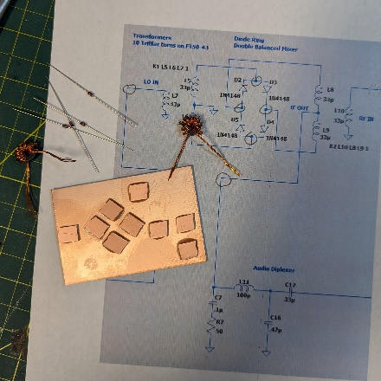
- Layout the board | 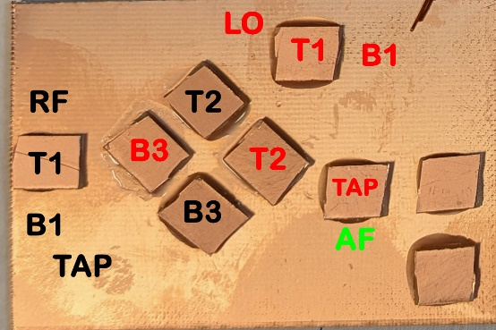
- Write on it! It will help. | d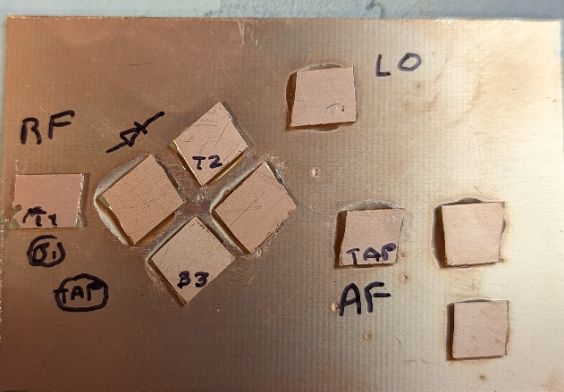
- Solder in the diodes – watch the direction -anode to cathode | 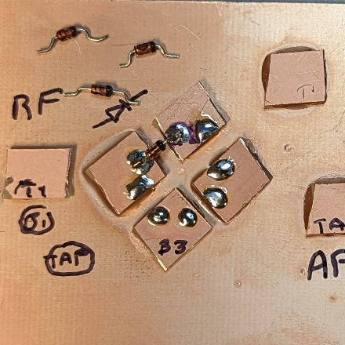
- Transformers – The tap is pre-solderd, primary is twisted, the other tow leads are loose | 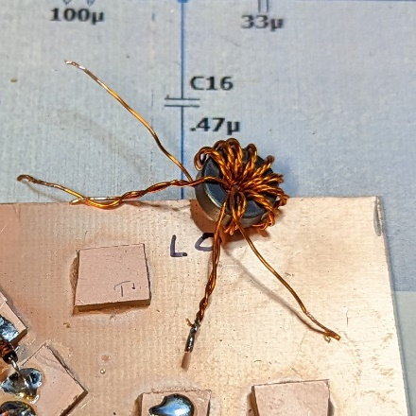
- RF transformer – solder the tap to ground | 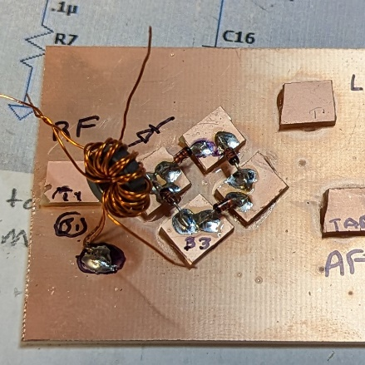
- One loose end to bottom pad, the other loose end to top pad | 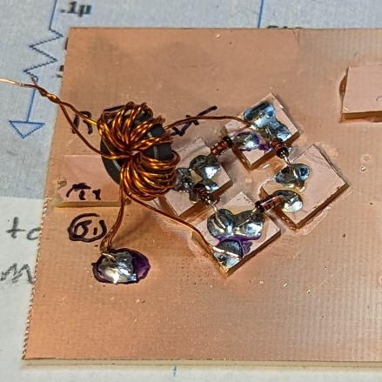
- Untwist the primary winding – solder one end to the RF pad and one end to ground | 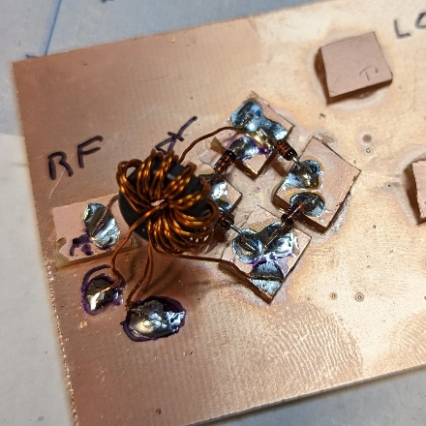
- LO Transformer – solder the tap to the AF PAD | 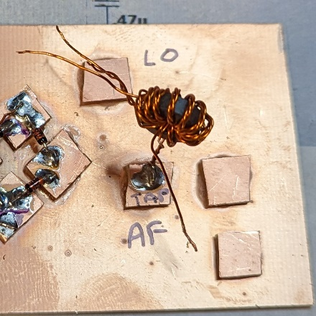
- One loose ending goes to the far pad – you may need to pull the transformer over slightly | 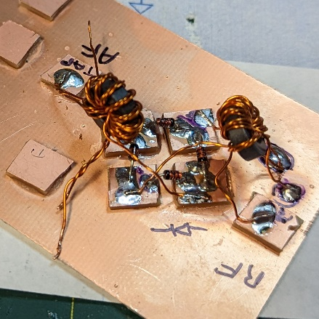
- The other loose winding goes to the near pad | 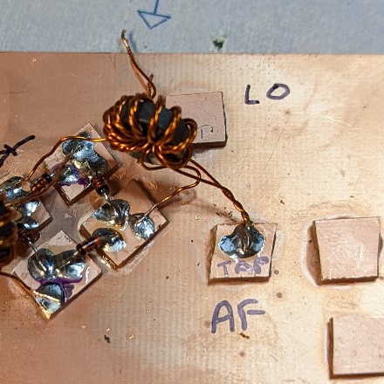
- Untwist the primary and solder one lead to the pad and one to groun | 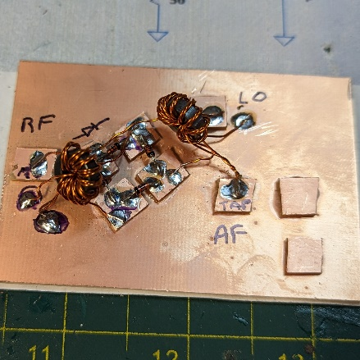
- Solder on some test leads. Ready to test | 